📝 Notes
Apr 28, 2026

Contained Animal Management System | Design Review 1
Invited Christian Ruiz Francisco Perez Tyler Morton Raul Montenegro Claudiu Constantin wyldsolconsulting@gmail.com
Attachments Contained Animal Management System | Design Review 1
Meeting records Transcript Recording

Summary
The team reviewed prototype designs and discussed MVP functional requirements with a finalized subscription model decision.
Prototype and Dashboard Review
The team reviewed the full platform prototype covering onboarding, dashboard navigation, and roster management. Feedback confirmed the table view requires structural changes to better accommodate large animal counts.
Feature and Financial Logic
Discussions centered on invoicing workflows, report customization, and subscription billing. It was decided that sent invoices will be inactivated rather than deleted to maintain financial integrity.
MVP Focus and Style
The project focus shifted toward mobile-first MVP screens including media management and animal onboarding. Design discussions favored modern typography paired with an earthy color palette for a professional aesthetic.

Rate this Summary: Helpful or Not Helpful

Decisions
We've updated the Decisions section using your feedback.
Let us know what you think: Helpful or Not Helpful

ALIGNED
- Custom fee category support The platform will support the creation of custom fee categories to accommodate specific user needs.
- Subscription billing based on active animals Subscription billing tiers are set to be determined by the count of active status animals.
- Design aesthetic as modern-rustic The visual design direction is established as modern typography paired with a rustic, earthy color palette.

Next steps
- [WyldSol] Check Availability: Verify Friday availability for scheduling purposes.
- [Claudiu Constantin] Send Update: Send asynchronous design update by Thursday end of day.
- [Francisco Perez] Schedule Meeting: Check team schedule for better Monday slot selection. Send finalized meeting invitation for Monday discussion.
- [WyldSol] List MVP Screens: Send finalized list of essential MVP screens for web and mobile development priority.
- [Claudiu Constantin] Share Assets: Map prototype screenshots into Figma file for commenting. Send the Figma link and prototype to reviewers.
- [WyldSol] Confirm Invoice Deletion: Determine the legal feasibility of deleting invoices already marked as sent. Inform the group of findings.
- [Francisco Perez, Christian Ruiz] Investigate API: Continue investigation regarding information sent to the API company.
- [Francisco Perez] Share Recording: Share the meeting recording and associated links in Basecamp.

Details
Did the screenshots in this section make your notes better or worse?
- Scheduling the Second Design Review and Asynchronous Update: The second design review has been tentatively scheduled for Monday, as Claudiu Constantin is unavailable on Friday due to Labor Day. Claudiu Constantin committed to sending an asynchronous update by the end of their day on Thursday, which will be discussed on Monday during a follow-up meeting. WyldSol confirmed availability for the Monday meeting from 8:30 to 9:30 a.m. Mountain time, and Francisco Perez will determine the best slot based on the team's schedule (00:00:49).
- Overview of the Full Flow Prototype and UI Examples: Claudiu Constantin presented a prototype of the full platform flow to check layout, navigation, and missing data or functionality. Following the prototype, they planned to present UI examples to discuss the visual direction, needed changes, and necessary additions. The onboarding process, including sign-in, sign-up, social login, and a forgotten password flow, was reviewed (00:01:40).
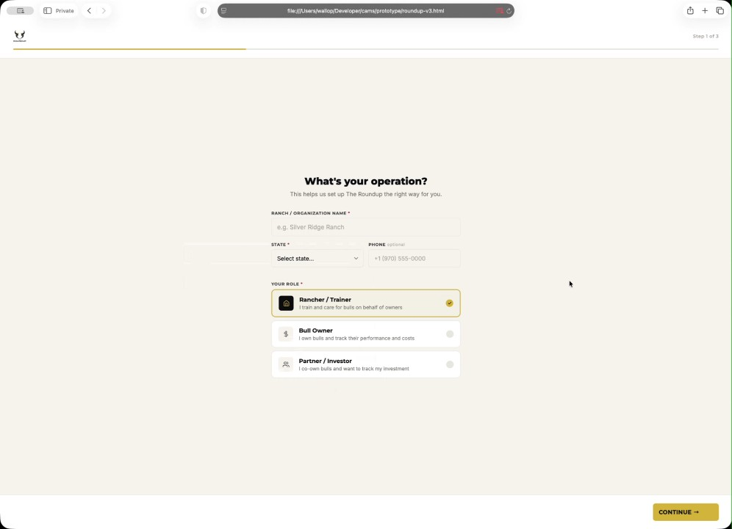
- Onboarding Steps and Initial Platform Landing: The onboarding process requires selecting a ranch/organization name, state, and contact information (optional), followed by selecting a role (rancher/trainer, loaner, or partner/investor). Users set their default invoice schedule (monthly, manual, or set up later) and have the option for autosplitting by ownership percentage. The final steps involve adding the first animal and ranch/owner details, after which users land on a dashboard (00:02:58).
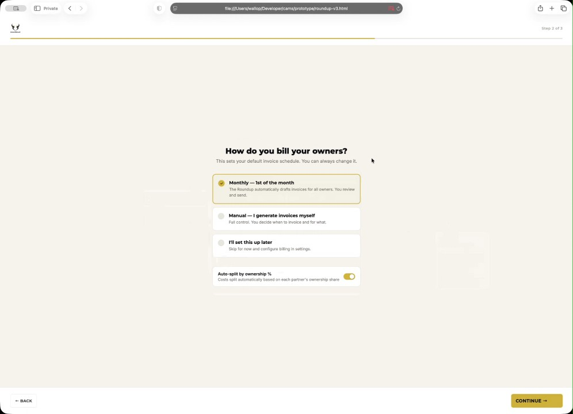
- Dashboard Features and Navigation: The dashboard highlights actionable items such as due invoices and animals with incomplete data, nudging users to review information. Quick actions include adding an animal, generating an invoice, uploading media, and viewing a ranch overview, alongside key statistics like active animal count, upcoming events, and recent activity. Navigation features at the top include a search function, notifications, and account management access (00:04:05).
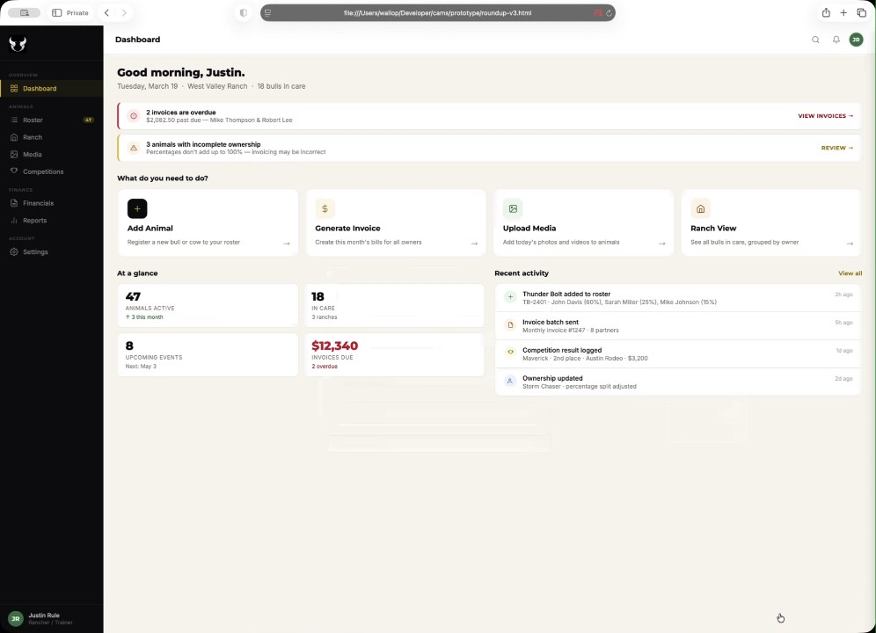
- Roster Table View and Animal Detail Page: The roster table view displays animal data with filtering and sorting capabilities by animal, brand, type, and status (active, in care, retired, etc.). Clicking an animal opens a detail page featuring a hero section with a picture, essential data (name, type, age), location, date of birth, and purchase price (00:05:44). The detail page also shows a breakdown of ownership percentages, lineage, media, tags, and competition history (00:07:02).
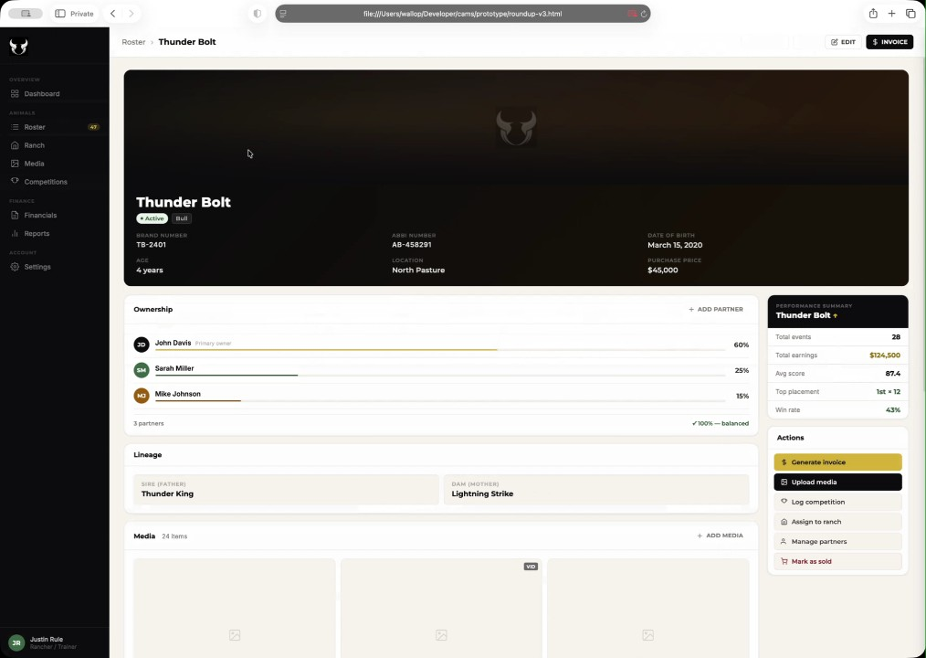
- Ranch Overview and Media Consolidation: The ranch summary section allows for exporting data, searching, and filtering by owners or statuses. WyldSol provided feedback that the current table view structure, which splits animals by caretaker, is not suitable because users may have hundreds of animals, with the majority having 50 to 200 animals in their care (00:09:25). Claudiu Constantin noted that they will restructure the filtering, possibly by showing a top listing of animals in care (00:10:47).
- Process for Adding an Animal: The process for adding a new animal to the roster is broken down into three steps: basic information (name, brand, type, owner, status), partnership and ownership split (ensuring total ownership reaches 100%), and media upload (00:12:17). Media uploading includes options for dragging files, taking photos, or recording video, with quick options for autotagging and marking media as private (00:13:31).
- Competition and Financials Tabs: The competitions tab features quick statistics, a view of results, and a schedule of events, including an option to register animals (00:14:40). The financials tab includes statistics on invoiced, collected, and pending/overdue amounts, with filters for status and month/year (00:16:07). A detailed invoice preview shows a summary, line items, and ownership split, allowing partners to view their specific portion of the invoice (00:17:26).
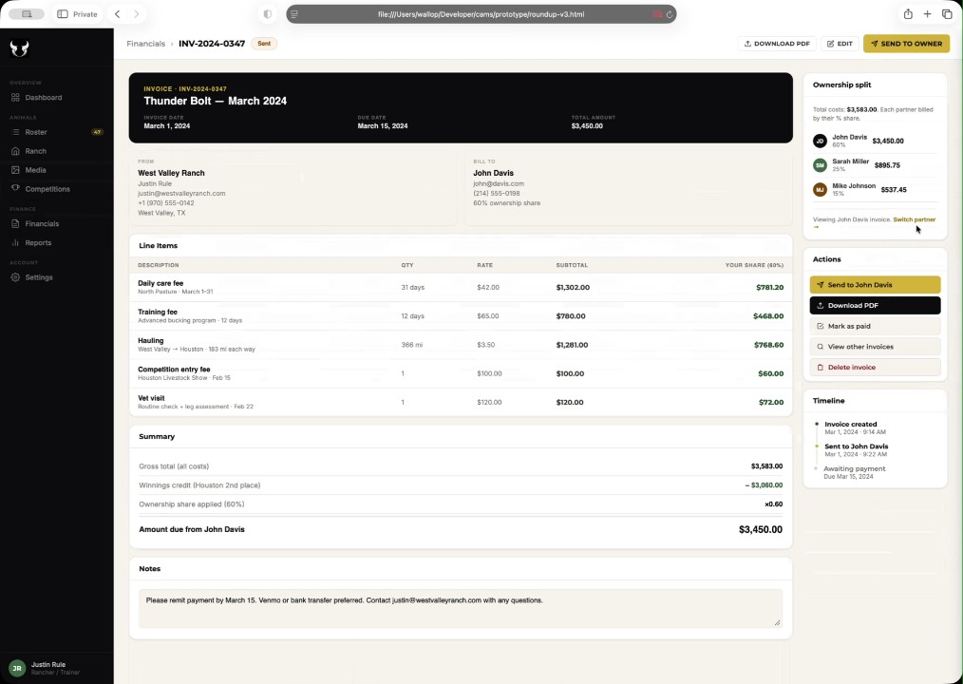
- Handling Sent Invoices and Deletion: Regarding the deletion of already sent invoices, WyldSol stated that they would not want users to be able to delete them from the system, suggesting inactivation as an alternative. Claudiu Constantin agreed to add a warning prompt to the user stating that once an invoice is sent, it is final to prevent potential frustration and support issues (00:18:42).
- Reports and Settings Area: The reports section includes an overview that can be filtered by season or time period, showing statistics like total winnings and score distribution (00:19:44). The reports can be viewed by animal and by owner, listing animals, gross billed amounts, winning share, net paid, and outstanding invoices. The settings area covers the ranch profile, default settings (e.g., daily care rate), user roles, permission management, and partners directory (00:22:07). WyldSol confirmed the need to customize fee categories in the invoice settings (00:24:57).
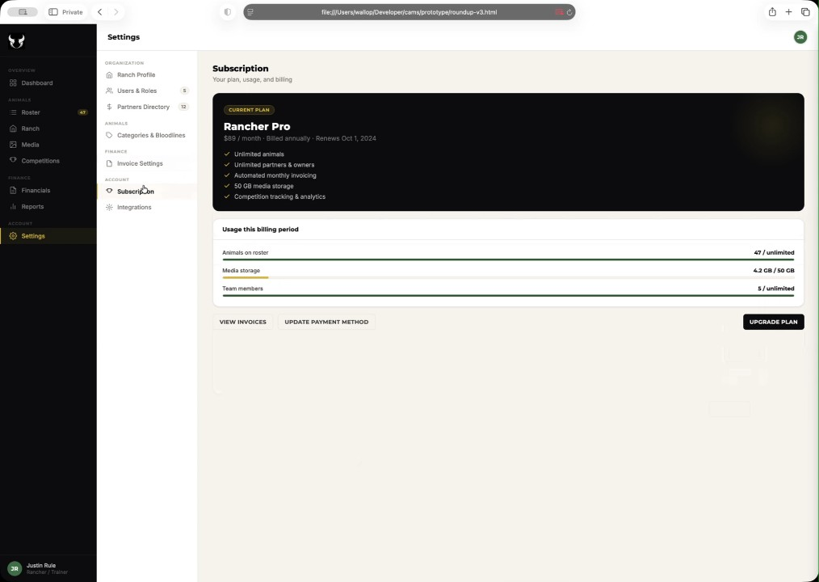
- Subscription Model and Charging by Active Animals: WyldSol introduced a new requirement for the subscription model, requesting that charges be automatically based on the count of active animals (00:27:38). Christian Ruiz confirmed the feasibility of counting active animals and charging the subscription based on whether the user is in a lower or higher tier (00:28:58). Claudiu Constantin explained that this modification will require a prompt when a user attempts to activate an animal that exceeds their subscription limit, requiring payment for the extra animals (00:30:07).
- Focus for Minimum Viable Product (MVP) and Mobile Design: Francisco Perez thanked Claudiu Constantin for the prototype, confirming that it establishes a direction for moving forward, while noting that the focus must shift to mobile-first screens for the main flows of the MVP (00:30:07). The key focus areas for the MVP include media management, animal onboarding, and some parts of the reports area (00:31:22).
- Review of Initial UI Design Samples: Claudiu Constantin presented initial UI design samples using a rustic but modern style, incorporating the provided colors (yellow, brown, beige) (00:34:05). The dashboard example featured a simple, light design with a sidebar that can be minimized to make more room for tables, particularly for use on tablet devices. WyldSol suggested the need for more contrast, especially around the quick actions and boxes, commenting that the current look felt "hospitalish" (00:35:29) (00:38:06).
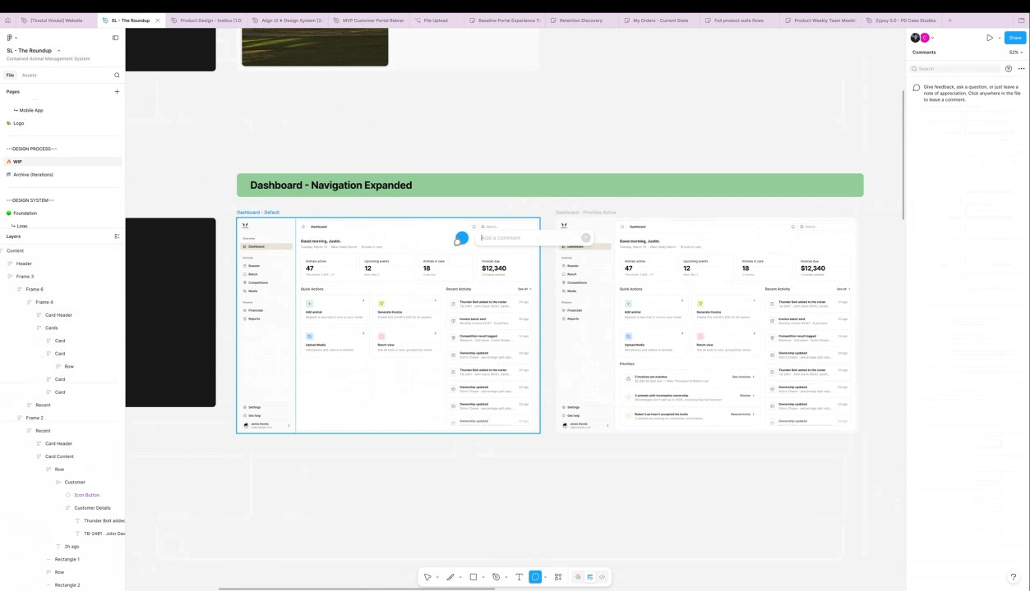
- Typography and Next Steps: WyldSol and Claudiu Constantin agreed to maintain a modern typography style while utilizing the earthy color palette. Claudiu Constantin committed to sending the prototype, the Figma UI link for review and commenting, and screenshots of the prototype screens mapped into Figma for detailed feedback (00:39:06). Francisco Perez confirmed that they are reviewing API-related information and will update the team via Basecamp (00:41:19).
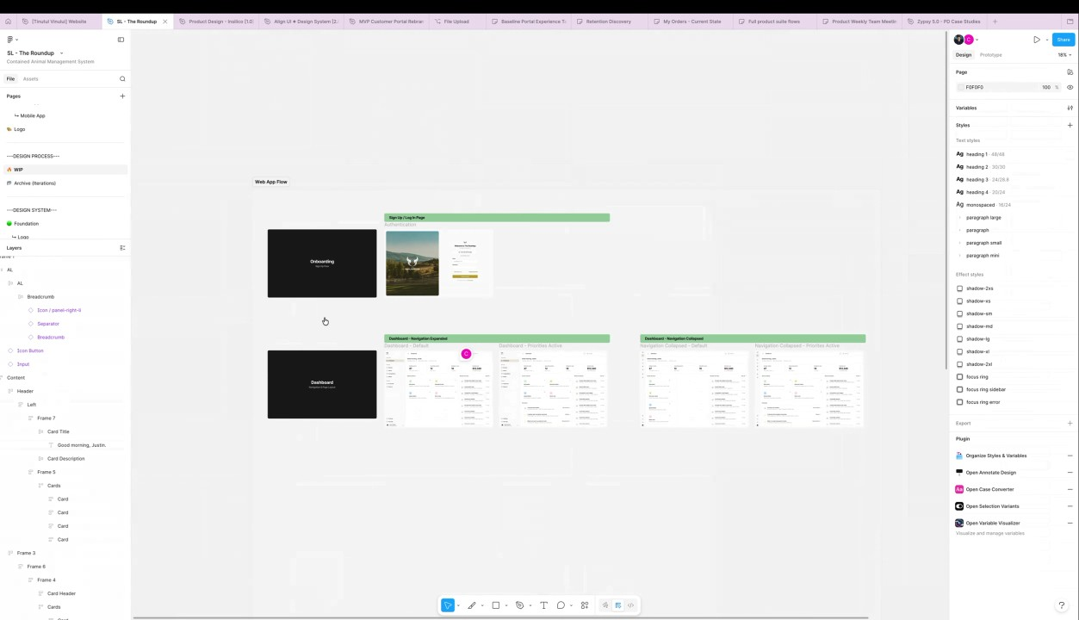

You should review Gemini's notes to make sure they're accurate. Get tips and learn how Gemini takes notes
How is the quality of these specific notes? Take a short survey to let us know your feedback, including how helpful the notes were for your needs.

📖 Transcript
Apr 28, 2026

Contained Animal Management System | Design Review 1 - Transcript

00:00:00

Francisco Perez: for the third sorry for the second design review. So today we have the first review and tomorrow we will have another workshop. Uh I think just to confirm you told me that on Friday uh you couldn't do anytime sooner than than 10:30 a.m. Right.
WyldSol: Uh, yeah, I think that's right. Let me double check.
Francisco Perez: Okay.
Claudiu Constantin: I won't be able to join Friday, by the way.
WyldSol: Yeah.
Claudiu Constantin: Just letting you know.
Francisco Perez: Yeah,
Claudiu Constantin: Uh I have a Labor Day,
Francisco Perez: that was Oh,
Claudiu Constantin: so it's free.
Francisco Perez: okay. Oh, it's also Liberty. Okay. Yeah, it's also liberty for for us. Uh,
Claudiu Constantin: Yeah,
Francisco Perez: so I guess we'll have to do that on Monday because I don't I don't I don't know if Thursday would be too short, Cloudy, for another update. I think it would be
Claudiu Constantin: Tuesday, Wednesday.
Francisco Perez: right.
Claudiu Constantin: What we can do is for Thursday I can send something async rather and
Francisco Perez: Okay.

00:00:49

Francisco Perez: Yep.
Claudiu Constantin: we can talk about it again on Monday while I present it and then maybe you already have some feedback and then
WyldSol: Okay.
Francisco Perez: Yep.
Claudiu Constantin: we can you know
WyldSol: Okay. Yeah,
Francisco Perez: Okay.
WyldSol: that worked.
Francisco Perez: Yeah, I think that that works. Um,
Claudiu Constantin: connect
Francisco Perez: so in that case on Monday, what is your availability like?
WyldSol: Um,
Francisco Perez: Uh,
WyldSol: I could do I could do 8:30 to 9:30 a.m.
Francisco Perez: okay. Right. Yeah,
WyldSol: Mountain.
Francisco Perez: I think those two slots work as options for us. So, I'm going to I'm going to see the one that fits better with the the team schedule and let's do that. Yeah. Let's uh send an update on Thursday, Clauddio. Thursday um end of the end of your day maybe and let's sync back on Monday to discuss
Claudiu Constantin: Yeah,
Francisco Perez: feedback. Yeah.
Claudiu Constantin: it's going to be your morning. So that's okay. Like I I'll send the first batch uh and then on Monday I'll still have time like

00:01:40

Francisco Perez: Okay.
Claudiu Constantin: first all my morning and afternoon until you guys wake up.
Francisco Perez: Sure. Yeah.
Claudiu Constantin: Um let me share my
Francisco Perez: Right.
Claudiu Constantin: window.
Francisco Perez: Yeah, let's get started.
Claudiu Constantin: this window. All right. So, what we're going to present for today is first uh a prototype of the full flow so that we can get into details, check the layout, check the navigation, if there's any data that we're missing, some any functionality that we're missing. So things like that, not necessarily design-wise. I will also present after the prototype some UI examples of a visual direction and then we can talk about what's missing when we need to change and stuff like that.
WyldSol: Okay.
Claudiu Constantin: Transcript. Perfect. So let's start with uh the onboarding process.
WyldSol: Yep.
Claudiu Constantin: So we have the sign in and the signup flows. Pretty standard social login. uh the forget password flow. So let's assume we want to create an account, right? Then we go through the on boarding.

00:02:58

Claudiu Constantin: We have the ranch and organization name. We have to select a state and a contact information which is optional. And you also have to select your role which is a rancher/trainer, loaner or a partner/investor. Uh once you select one of these data, we move on to the next step. How do you want to build your owners? This sets your default defaults invoice schedule. You can always change it. This also depends on what you're selecting beforehand, by the way. So we have monthly, manual, or I'll set this up later. And an option here that you can also change into your account settings, which is autosplitting by ownership percentage. We move on. And this is just us getting ahead of the user, right? So, let's add your first animal. Uh maybe more details about the ranch and who the owners are. Of course, you can skip this step and then uh you can go into the roundup platform. Once you do so, you land on a dashboard.

00:04:05

Claudiu Constantin: In this dashboard, we're overlooking uh certainable actions that you have here on the on the top area. For example, some invoices are due. You have a way to action upon them. Some animals that I have don't have 100% correct data. Invoicing might be incorrect. We nudge the users to review. We have a list of quick actions here as well. So, you can quickly add an animal. You can generate an invoice. You can upload media or you can see an overall uh view of your ranch. Then we have some glancible stats. Uh for now I've added how many animals you have active if there's less or more um for this month. So basically a trend line. uh how many upcoming events and when it's the first event upcoming. So 3rd of May for example. Also an overview of how many invoices are due. Uh and a way to see recent activity. Basically, uh, if someone added something to the roster, if an invoice invoice was sent, if a competition wrapped, then you have the results logged in, etc. Besides that, we also have a way at the top to search, notifications of course, and a way to manage your account, which will include account settings, password, uh, payment methods, things like that.

00:05:44

Claudiu Constantin: But I didn't really go into the details uh for now into that area. Um next we have the roster roster table view pretty clear on the data we're showing. Of course you have filtering system so you can quickly search for any data that we display here. You can also uh have multiple options to filter. I haven't done the filtering yet but it is here. So you can of course filter by animal, brand, type uh and so on or you can sort by any of these table uh view or you can of course click on the table header and it will sort ascending or descending based on the column row where it makes sense. Of course you can also quickly filter by status uh here. So active, in care, training, retired, sold uh etc. And of course, if you tap on an animal, you can see a big uh hero section with a picture of the animal. Right now, I haven't I'm just using a dark press placeholder. Uh but this is where the picture would be, name of the animal, if it's active, and what type, number, age, and some other key data here, right?

00:07:02

Claudiu Constantin: like uh number, location, date of birth, purchase price and so on. You also see a breakdown of the ownership and who's the primary owner and other uh percentages that are uh broken off. We also have a summary here saying how much just in case there are more and it's hard to count and if the percentages percentagees are balanced or not meaning they add up to 100%. You can also add another partner of course if you want to. You can also see the lineage and you can also see all the media for this specific animal and if it's a picture or a video you can quickly add one if you want. You can also see all the tags for this specific animal and you can add a tag as well. Just in case you want to search, for example, if I want to search here at the top bar and I know the tag for this specific animal, it will show up if I search for this tag. We also have a competition history with event name, date, score, place, and winnings.

00:08:10

Claudiu Constantin: You can add the result manually of course and some notes here uh if you want to add some notes for the animal itself. We also have a sidebar here which shows a quick summary of the animal itself. So that means total events, total earning so far, average score, best placement and how many times and a win rate. Besides that, we also have some actions here. First one is generating invoice. You can upload media same way as you would do do here. You can assign it to a ranch if not assigned. You can manage the partners or you can mark it as sold. Uh I haven't created the flows for this yet except for generating an invoice. Uh but I'll get back to this in a second uh while I uh finish presenting the ranch part with the roster. Uh of course you can edit and again you have an invoice here. Uh I had one important question actually I I'll go over the questions afterwards. I'll come back to that.

00:09:25

Claudiu Constantin: Moving on to ranch. Same idea summary at the top. You can export or assign a you can search uh you can filter by all owners or statuses. The currently the animals are split between uh people that have them in care. One improvement I want to do here is actually there's a question for you. On average, how many animals do you think someone will have in their care? Like, does it go up to
WyldSol: Yeah, it goes up to hundreds. I mean,
Claudiu Constantin: hundreds?
WyldSol: the majority of the users are probably going to be into like 200 to 500. Um, sorry. The majority is going to be like a a 50 to 200 um animal range. And then you have, you know, not so common 200 to
Claudiu Constantin: Okay,
WyldSol: 600.
Claudiu Constantin: I get it. Then uh uh the table view is okay. I just need to restructure the filtering a bit because splitting them like this uh by uh caretaker doesn't make sense if you can have up to 100 because then you will never reach the bottom of the caretaker.

00:10:47

WyldSol: Yeah.
Claudiu Constantin: Right? So, what I'm going to do is I'm probably going to either show top listing
WyldSol: Yeah.
Claudiu Constantin: of or most most recent animals in care, which then you can ultimately open a new page and see a full list. But,
WyldSol: Yeah.
Claudiu Constantin: uh we'll see on the next uh but uh I'll think about this for our next presentation. But for now, uh we can validate the data anyway because the table columns probably won't change. So we have the name of the bull, rand, status, intake, days in care and location. Quick actions to edit or see more. And you can see you can also view invoice or you can generate invoice for the caretaker itself. Um, of course clicking on it brings us back to the roster detail page. Um and then we have the media page which basically consolidates all the media that we have and you can quickly filter by animal names types media type of course uh event type if there's a tag of such uh visibility if it's public or private and tag owner if applicable.

00:12:17

Claudiu Constantin: animal. If you click on it, it will go to the animal itself with the image open. I just haven't added that functionality yet. Uh, of course, you have some quick filters here, either by uh recent or untagged, or you can search by animal, tag, date, and so on. You also have a way to add uh animals or media. But let's say I want to add an animal, right? I go here, add an animal to the roster page. I'm just going to click click it again in case we don't see it. And here we're breaking this into three different steps. Step one, it's just basic information with optional stuff. Name, brand, type, primary owner, uh codes, date of birth, but these are all optional. bloodline and location. Also a status which is active in training in care. You can also save and finish later which sets it into a draft mode or you can just continue with the next step step two which is uh partnership and ownership split.

00:13:31

Claudiu Constantin: So you can set percentages for each partner most total or 100% of course before you can save and it will let you know here if it's not and you can tweak quickly here you can add another partner as well and a short area where I can inform the user on how splitting works. Next would be media. So of course uh I've left you can upload the media here by dragging the photos or you can take a photo record. I left this here on desktop uh intentionally because uh these are mostly mobile options of course or tablet but I didn't want to hide them because I don't have uh mobile views yet. I'll have them for our next section or maybe on Thursday async. Uh but you can quickly take a photo, you can quickly record the video if you want to. Uh you have some quick ways of autotagging the media itself with most recent most used and marking it as private which means it's not shared with partners. You can either skip the media of course or you can save the animal.

00:14:40

Claudiu Constantin: And that is it for the animal part. Then we have the competitions tab. Short stats in the beginning at the top. How many events also quick insights into history total winnings average scores and if you're up upwards trending or downwards and a win rate of the events. Then we have a results view and also a schedule view. I'm going to go over the results view first. Same way as the others for tables, search, filtering, uh quick filters here as well. Animal table with various data. Uh we have a list of top performers and you can of course click and see a view of them all and you also see a widget here with upcoming uh schedules/event and clicking on the shortcut of course we'll switch to the event page and here we can see a list of the events with highlighting the dates most recent one first of course name description uh uh animals registered and you have a quick way to register one another animal if you want to or you can see an overview.

00:16:07

Claudiu Constantin: You can see an insight here sorry saying that you don't have any registered so you might want to add more. Of course you can add an event just to uh keep track of them. Uh if we have a way to maybe add them automatically, that would be even more uh amazing. Maybe there's a public list that we can pull info from and we can add them here and you can participate by registering your animal. Um moving on to financials. So financials again uh we have some quick stats at the top. So how many you have invoiced, how many you have collected, how many invoicings are pending or overdue. We have some quick filters here at the top which is all drafts, sent and paid. You can quickly search by invoice ID or owner. You can filter by statuses or month/ear and of course uh columns for the table. Invoice number, owner, animal, invoice date, due date, amount, and status. You can export quickly which gives you a view of the invoice itself.

00:17:26

Claudiu Constantin: You have a header doing a summary of the invoice. Just typical invoice preview I would say from build two line items which with each of the items you can edit of course on click. You have a summary here and notes if you want to add some custom notes. You also have a sidebar here which shows an overhip ownership split. So each partner is built by the percentage split right. So, John Davis gets this now. Ser gets this and so on. You can also switch to view the invoice from a specific partner. For for example, we're now seeing John Davis's invoice. You can click here to switch between the rest. We also have some quick actions here like sending uh the invoice through mail. You can download the PDF. You can mark as paid or other options depending on the status of the invoice. you can view the other invoices which is basically this quick switching and then you can delete the invoice as well. Uh here's an edge case I would like to talk about regarding already sent invoices.

00:18:42

Claudiu Constantin: Like I'm not sure if legally they're able to delete them or not based on the invoice
WyldSol: they've already sent them. Um I don't know legally,
Claudiu Constantin: number.
WyldSol: but I don't think we'd want to be able to delete one that's already sent.
Claudiu Constantin: Yeah.
WyldSol: Um we could probably um like inactivate it,
Claudiu Constantin: Okay.
WyldSol: but I don't think we'd want to take it out of the system. So, let me double check on that.
Claudiu Constantin: Okay, because then I can add a warning like once you send this it's final in that sense.
WyldSol: Yeah.
Claudiu Constantin: So they know they have time to oh wait let me double check to avoid any frustrations or contacting support and so on.
WyldSol: Yeah.
Claudiu Constantin: You also have a timeline here showing when the invoice was created if it was sent or not. still awaiting payment and of course if you receive payment it will update with the date
WyldSol: No.
Claudiu Constantin: received. Um yeah okay you can also download a
WyldSol: That's
Claudiu Constantin: PDF. This is the these are the financial parts.

00:19:44

WyldSol: nice.
Claudiu Constantin: You can also generate invoices of course they will use the same layout. I haven't gotten to that area specifically yet but it will be like build your own invoice right you select your line you add it. So it will be pretty straightforward. Then we have the reports. Oh, one second. Yeah. Okay. Then we have the reports. And here we have a submen which is split by an overview similar to the dashboard or you can see by animal. So performance breakdown performance breakdown from competitions and then some finance area with earnings and by owner. Let's go with overview first. We have a season overview and you can select season 30 days, 90 days or all. Um some stats at the beginning, total winnings, events, average score, win rate and so on. Basically, some data will be repeated from the competition area for example. But this is just a way to generate reports based on that specific data. And you we have several widgets here, right?

00:21:00

Claudiu Constantin: So winnings by month uh with a bar chart showing best month and an average also a trending line let you know that you're in a good spot and trending up or down uh score distribution. So excellent, good, fair, or below. And you can see how many events and how much that takes up as percentage. And you also have a top uh you you also have a table view of top animals by earnings. And you can see the name, events, average score, how many wins per animal and the win rate of course and total winnings. Um, of course, if you click on it, it will go to the animal itself and you can look for more data. But uh let's go back to reports. Then we have the view by animal, right? So you have some quick ways of uh switching them by filtering system at the top. Of course you can again filter by season or 90 days, 30 days or all time. Um and if you filter you will only see uh results from that animal.

00:22:07

Claudiu Constantin: Then we have competitions here again top area with uh relevant stats. table view of event name, which animal has participated, date, score, place and winnings. Uh then we have earnings in general, winnings and invoicing summaries. Uh these are just monthly reports um as an overview either for the season or all time. Nothing too crazy. And then we have by owner as well. So first column is owner. Then we have list of animals in uh in this person's ownership uh gross build, winning share, net paid and outstanding if you still have money to invoices to send to the specific person. Besides that, we also have the settings area. And here we have the ranch profile. Some basic information that we grab from here, website, contact email, state, name, and so on. Some default settings that the platform will use, right? So maybe the daily care rate current in and in what currency dollars for now but in case you want to expand you can add more school year start. Uh then we have the user roles which can be broken down by rancher, buller, partner.

00:23:37

Claudiu Constantin: Uh and this is a view on how it looks like when it's invited as a partner. Still doesn't have uh hasn't accepted the invite so it's still pending. You can invite users from here on top right. And here you can also manage your permissions. So what person which role can do what? So rancher for example you have an overview here. You can view all animals add edit view financials generate invoice and so on. And then have bullowner partner and uh depending on what other roles you have these will update accordingly. We have the partners directory as well and you can see an overview here of your partners. You can add, remove, etc. You have a way to manage your animals, right? So, what type of animals you have, you can add more, add less. Uh, you can add bloodlines. Um, and you can also add custom animal statuses just in case they want to personalize the platform, right? Um, then we have invoice settings. So, uh, standard details such as when the the billing schedule is, if it's something that we want to automate or if we want to do them manually.

00:24:57

Claudiu Constantin: Just to keep in mind that the automation itself just do drafts for everyone. You still have to review and send them. Invoice prefix and payment terms.
WyldSol: Okay.
Claudiu Constantin: We also have standard fees that you can set up here. So, daily care, training fee, holding and so on which you can tweak. Uh let me know if we want to customize the fee categories in case like we're covering only these ones, but maybe we want to add some custom ones that are maybe specific.
WyldSol: Yeah, we do.
Claudiu Constantin: Yeah.
WyldSol: Yeah, we
Claudiu Constantin: Okay. Just quickly write this down.
WyldSol: do.
Claudiu Constantin: All right. Uh, moving on to the subscription. I know this wasn't covered in on boarding process uh but I I kind of skipped it for now um just to show the more relevant uh data but of course they will have to pick a subscription and they will see their data here in the subscription area their current plan they have a way to upgrade and of course they will see an overview of what they can actually do based on the subscription they pick right so they might have limits to the roster team members media storage and so on.

00:26:30

Claudiu Constantin: Uh they can also update their pay payment method from here and they can see uh their list of invoices uh they sent to the platform. We also have an integrations here as well uh where they can manage for now. They're just coming soon as a preview and yeah we can expand this list uh as much as we want and we can connect them through the standard integration flow. Uh so I tried to cover as much as I could from
WyldSol: Okay.
Claudiu Constantin: uh all the data that you sent to me and I it was very valuable. So thank you for that.
WyldSol: Nope.
Claudiu Constantin: Um any questions for before I move on to showing some UI
WyldSol: Nope.
Claudiu Constantin: stuff.
WyldSol: Wait. One. Um.
Claudiu Constantin: You you you'll be able to review this afterwards as well. Uh, I'll map these into Figma just as a short parenthesis with uh screenshots and you
WyldSol: Okay.
Claudiu Constantin: can I I'll send you the file as well so you can click and play around. But I'll also need to add it to Figma so you're able to add comments on a specific area,

00:27:38

WyldSol: Okay.
Claudiu Constantin: right?
WyldSol: Okay.
Claudiu Constantin: Because I think that would be easier to pinpoint specific uh feedback
WyldSol: Yeah.
Claudiu Constantin: points.
WyldSol: Um I have one question.
Claudiu Constantin: So I'll do that tomorrow.
WyldSol: Okay. One question. Um not necessarily to this but maybe more for Christian. Um on the what he was just showing for the subscriptions. Um I want to do it by how many cows you have. And so if you have one to 50, you're you owe or you know you're paying this much active. If you have 1 to 50 active status animals, then you pay a certain amount. If you try to put in number 52, 53, um, I'm going to charge you for those. And so, can is there a way that we can automatically see active and charge appropriately for the subscription instead of the upgrade, which I know I had, but then I kind of changed my mind on charging them by the head. So, that's probably how I'll run the subscriptions.
Christian Ruiz: Yes. Yes. I mean, you meant by the status of the of the

00:28:58

WyldSol: Mhm.
Christian Ruiz: animal.
WyldSol: Yeah. So, we'll have a couple of um system statuses. Active would be one of those,
Christian Ruiz: Uh-huh.
WyldSol: and that's what we'd go off of is the active count.
Christian Ruiz: Yeah. I mean, I think I I understood correctly. And so basically it would be kind of like counting the the active animals that we have and based on those we charge uh in the
WyldSol: Mhm.
Christian Ruiz: subscription.
WyldSol: Yeah. You're either in a lower tier or a higher tier depending on how many animals you
Christian Ruiz: Yeah. Yeah.
WyldSol: have.
Christian Ruiz: Absolutely.
WyldSol: Okay.
Christian Ruiz: That's all.
WyldSol: Okay. Sorry, Cloudo. I didn't send that to you. Um,
Claudiu Constantin: That's fine. That's fine.
WyldSol: so I just had that and you know when you brought that up I was like,
Claudiu Constantin: That's fine.
WyldSol: "Oh gosh, I forgot to say
Claudiu Constantin: Uh no worries because uh the implications here are basically only for me
WyldSol: something.
Claudiu Constantin: to detect or not for me to detect but to add a screen that's once we detect that they want to go over when they try to add an animal and switch it to active and it's over their limit.

00:30:07

Claudiu Constantin: We need to prompt them letting them know that, hey, you're above the limit. You can still add it, but you have to pay X amount for each new animal you add.
WyldSol: Yeah. Yep.
Claudiu Constantin: And that means also showing them here as a separate billing area, as extra animals or something like
WyldSol: Yeah. Yeah. Yep.
Claudiu Constantin: that.
WyldSol: Okay. Perfect.
Francisco Perez: Yep.
Claudiu Constantin: But this can be easily tweaked as we go.
Francisco Perez: Before we move on to the UI uh screen slot, I just wanted to mention that um well, thank you for for this the prototype and this really gives us an idea of what we want to move towards and allows us to get feedback on the direction in general. Right? I think it's it's a pretty great tool to identify if we are, you know, on the right track or not. kind of like setting this as the the the ideal scenario of having a lot of screens and and almost all of the flows completed. Right? So uh the other thing is that uh we are going to work walk towards this uh objective with the UI designs that Claudia is going to be showing later and uh just as as Cladio mentioned uh we focused on the web parts for this prototype because it covers like the whole flow but the idea is that we also focus on the mobile first screens

00:31:22

WyldSol: Yeah.
Francisco Perez: um for for the main flows for the MVP which I think are the ones that we want to focus most on in terms of the the actual designs. Uh but yeah, this gives us a pretty good big picture understanding. So, thank you very much.
WyldSol: Yeah. Yeah. It's nice.
Claudiu Constantin: uh do you think you want to go over what we deem to be uh very important for the MVP phase for the solution lab uh or should we do that in the next workshop? What do you think, Frank?
WyldSol: I was going to send that list today um on the screen.
Claudiu Constantin: Oh, okay then.
WyldSol: So probably next workshop I
Claudiu Constantin: Okay,
WyldSol: guess.
Claudiu Constantin: then that makes
Francisco Perez: Let's sync on that next workshop.
Claudiu Constantin: sense.
Francisco Perez: But it should be mostly the media management value for the and the on boarding of the of the animals.
WyldSol: Yep.
Claudiu Constantin: Okay.
WyldSol: And a little bit of your reports area.
Claudiu Constantin: And mobile and desktop, of course.
WyldSol: Yeah. But not not too much of the reports.

00:32:19

WyldSol: Just
Claudiu Constantin: Uh I think what's essential here is that I try to cover even design-wise and some flows uh bits and pieces that all connect right so that there's
WyldSol: Yeah.
Claudiu Constantin: no point in me focusing on building 10 tables if we already have a table view and the prototype because we already know how it looks like we can adapt it. So we can focus on key edge cases so that we can uh have a bigger picture
WyldSol: Yep.
Claudiu Constantin: and to have a at least a flow that makes sense maybe for reports, media and on boarding. Um all right, let me close this share screen so I can share some Figma Figma stuff. Is there a way to actually change it from here? Yeah. Sure again. Sure. Come on, Google. You can do it. Uh, I think it worked now. Okay, perfect. All right, so now we're just going to see a sample of some screens. Um, just to get the idea of how it could look like and if we have any initial feedback before I move on and applying that idea to the rest of the screens that we just saw.

00:34:05

Claudiu Constantin: Keep in mind that some elements might shift or change as you saw, for example, for the load logging screen. The other option had something in the middle pretty stark with some uh features on. Uh I removed the features, but we can totally add them back somewhere in this area. But for now, I was thinking that maybe we could go with this rusticish but modern uh style of imagery on the left, the forms on the right. And once you continue and you create your account and do on boarding, it will become like a full screen like you saw in the prototype.
WyldSol: Mhm. I like
Claudiu Constantin: So, uh I've kept the colors that you sent.
WyldSol: that.
Claudiu Constantin: So, uh yellow, brown, um light hues of beige, I would say. Uh they were here, right? Uh I'm thinking of adding maybe one more accent color for the menu but I will propose that in the next session. But first let's see with this.
WyldSol: Okay.
Claudiu Constantin: Then we also have an example of the dashboard. I try to keep it a bit bigger and simple by default but easy to uh react on and see what what is what.

00:35:29

Claudiu Constantin: For example, sidebar here on the left, logo option items clearly spaced some uh navigation at the bottom left with settings and getting help at the top. Uh we have the title of the page. So basically breadcrumbs. By the way, let me know if I should zoom in a bit more if you don't see it.
WyldSol: No, I'm good. I made it full screen.
Claudiu Constantin: Okay. uh notification area, search the typography here at the top, uh the stats area, quick actions that I've showed, and the recent activity. Uh I intentionally kept it kept it light uh just to see what your thoughts is on uh are on this specifically and if you think that we should go more bold or less or even if we need more contrast based on the target group that you
WyldSol: Yeah, I think we need a little more contrast specifically around the
Claudiu Constantin: know
WyldSol: actions or the
Claudiu Constantin: so maybe the the button themselves. Actually,
WyldSol: boxes.
Claudiu Constantin: let me quickly showcase what I mean. So maybe this could be rather a secondary option or even primary, right?

00:36:56

Claudiu Constantin: So you can easily see that they're clickable. Being interactive will help because once you hover over them,
WyldSol: Yeah.
Claudiu Constantin: all of the this window will interact. So it will light up. So we'll see about that.
WyldSol: Yeah.
Claudiu Constantin: Um, I will try to maybe add more depth to it. I I really want to send this feeling across.
WyldSol: Yeah.
Claudiu Constantin: Like whenever I look at this image, I I like the feeling that it gives me and and the colors, which we actually reuse in the app,
WyldSol: Yeah.
Claudiu Constantin: which I think is a nice touch. And I could probably add more of these earthy colors to it in certain areas maybe if uh Mhm.
WyldSol: Yeah, it feels kind of
Claudiu Constantin: Let me revert this.
WyldSol: hospitalish.
Claudiu Constantin: Okay. Okay. Then that makes sense. Uh I also added a way to minimize of course the Why did this break? Hello. Sorry about this. I don't know why I just decided to break my Okay, auto layout something that sometimes does this or even with text.

00:38:06

Claudiu Constantin: Figma has some bugs like sometimes it would break my text and like oh why and I have to click on it for it to wake up. Uh uh but yeah, I also added a way to minimize the sidebar of course just to make more room because some tables I saw are kind of big and on some
WyldSol: Yeah.
Claudiu Constantin: maybe tablet devices this will be very handy.
WyldSol: Yeah, I like that.
Claudiu Constantin: Uh we won't have this issue on mobile of course because we're going to adapt them
WyldSol: Yeah.
Claudiu Constantin: and regarding tables on mobile we're probably not going to have tables because they're kind of bad to work with and they're they're probably turn into cards similar to this one.
WyldSol: Yeah.
Claudiu Constantin: But we'll see we'll see them when we get there.
WyldSol: Okay.
Claudiu Constantin: Uh so let me add a few comments here. Feel free to add them as well once we send the links uh when you you know look at them in your own
WyldSol: Okay.
Claudiu Constantin: time and maybe some ideas pop in through
WyldSol: Perfect.
Claudiu Constantin: hospital

00:39:06

WyldSol: I'll try to find better words, too.
Claudiu Constantin: the guidance that you sent actually helped comparing your opinions on this or that.
WyldSol: Oh,
Claudiu Constantin: Uh,
WyldSol: good.
Claudiu Constantin: so I'm trying to find a middle ground um that we can agree on, but uh for now that's good feedback. Um, what about typography? Do you think we should go more into this rustic style or do we still want to keep it modern?
WyldSol: I think we want to keep it modern.
Claudiu Constantin: Okay, I agree. I I like the idea of modern typography, but maybe uh rustic colors, earthy colors, right, with this uh approach.
WyldSol: Yeah.
Claudiu Constantin: All right, so uh this is what I've had for today. Um I'll be sending over the prototype. I'll be sending over the Figma link as well,
WyldSol: Okay.
Claudiu Constantin: so you can check the UIs and leave comments if you think uh if you have any new ideas. Um, do you know how to leave comments in Figma, by the way? Yeah. Okay, perfect. No need to show you that.

00:40:18

WyldSol: Yeah.
Claudiu Constantin: I'm also going to take screenshots of the prototype you just saw so that once you click play around, you can also see them in Figma one by one and you can leave comments on each of the screens if some of the flow is wrong, missing data, text corrections if applicable, but we can change them. We can change those into UI as well because because as you saw as I go and actually do the UI some elements might shift uh which is normal uh maybe I while I'm working on it
WyldSol: Yes.
Claudiu Constantin: and I get into the flow I detect that you know what this might be a better way to approach it and I'm I'm going to do that because it feels more natural. So that might happen just for you know so don't take the prototype literally as the final UI.
WyldSol: Okay.
Claudiu Constantin: It's just more of navigating and seeing if it connects nicely and it makes sense.
WyldSol: Okay.
Claudiu Constantin: Uh not all functions are available so you won't be able to export you know like or maybe

00:41:19

WyldSol: Perfect.
Claudiu Constantin: filter precisely but just to get the general idea.
WyldSol: Yeah. Okay.
Claudiu Constantin: Uh yeah that's all from my
Francisco Perez: Yep.
Claudiu Constantin: side.
Francisco Perez: Thank you very much, Clauddio. I don't know if there's any other comment before we leave it here.
WyldSol: No, I'll get you the list of screens um for MVP on web and mobile, but knowing we're going to do mobile first.
Francisco Perez: Okay.
WyldSol: Um I don't have any other questions on my side. I know I'm I have a action to let you know about delete on the invoice.
Francisco Perez: Right.
Claudiu Constantin: Yeah.
Francisco Perez: Yep.
Claudiu Constantin: Yeah. No rush. It will take a bit until I reach that stage, but want to
Francisco Perez: All right. And on our end, we're still reviewing the information also the the we saw the the things you sent to the
WyldSol: Okay.
Francisco Perez: API um company, right? So,
Claudiu Constantin: Just think
Francisco Perez: we're going to be also working on that with Christian regarding the the investigation.
Claudiu Constantin: about
Francisco Perez: But, uh yeah, if there's any update, uh we're going to let you know in Basecam. I'm going to be sharing the links to the the the the recording and

Transcription ended after 00:42:28

This editable transcript was computer generated and might contain errors. People can also change the text after it was created.

